The Composite Index of Relative
Change (CIRC): Identifying
Change in NDC areas

NDC National Evaluation
Phase 2

2011


The Composite Index of Relative Change (CIRC): Identifying Change in NDC areas

NDC National Evaluation
Phase 2

Centre for Regional Economic and Social Research
Sheffield Hallam University

Christina Beatty
Paul Lawless
Ian Wilson

2011

Contents

1. Introduction 1
2. Methodology 2
3. Change across NDC areas 5
4. NDC areas seeing most and least change: a detailed analysis 8
5. To what extent does deprivation determine change? 10
6. Progress over time 14
7. Change across clusters of NDC areas 15
8. Detailed analysis of each cluster 19

1

Introduction
The NDC Programme consists of 39 NDC areas located in 38 local authorities across all 9 Regions in England. Partnerships set up in each of these areas implemented different set of interventions across the Programme's six outcomes. Three of these outcomes are place-based: improving the fabric of the local housing stock and the local environment, reducing the incidence of crime and enhancing a sense of community; and three people-based: improving residents' skills and educational attainment, helping them to compete in the workforce, and introducing healthy living initiatives or enhancing access to health services.
The complex nature of the initiative, contrasting circumstances across areas, and the implementation of varying sets of interventions makes it challenging to assess relative change across the 39 areas. But it is important to do this for two reasons. First, because large gains in specific outcomes achieved in some NDC areas can be averaged out by lesser gains in others, leading to relatively small changes at the Programme wide level: success stories at the level of the individual NDC area can therefore be lost within the wider picture.
Second, unlike previous ABI evaluations, the NDC evaluation had access to change data for all schemes from a common baseline. This evidence-developed below-can also be used to help, at the margins, explain why some areas saw more change than did others, full results of which are outlined in Volume 5 of the final evaluation reports published in 2010.However, it should be stressed here that analyses outlined in this report are concerned with change across NDC areas, and not about the performance of individual NDC Partnerships. As is evident from Volume 5 of the final reports, it is difficult to establish exactly why NDC areas did change through time. Even when it is possible to identify factors which help explain relative change across the 39 areas, few of these anyway fall within the remit of Partnerships. Deprived areas such as the 39 NDCs change for many reasons, few of which are within the control of local regeneration agencies such as NDC Partnerships.
The following issues are explored in this report:
- Ch 2: methodology
- Ch 3: change across NDC areas
- Ch 4: NDC areas seeing most and least change: a detailed analysis
- Ch 5: to what extent does deprivation determine change?
- Ch 6: progress over time
- Ch 7: change across clusters of NDC areas

Methodology
In order to understand patterns of change across the 39 NDC areas, a Composite Index of Relative Change (CIRC) has been devised systematically to combine a range of outcome data. The CIRC standardises and combines change data for 36 core indicators which reflect changes which might plausibly be achieved during that six year period for which the evaluation had change data: 2002-2008 (Table 1). The biennial household survey is the primary source for most of these indicators. The four surveys, the first of which was carried out in 2002, provide consistent data for 31 indicators across all NDC areas from 2002-2008. The remaining five indicators are drawn from administrative data sources: DWP data on those claiming key worklessness benefits (1999 to 2008), and Key Stage education data from 2002 to 2007.
The CIRC measures, standardises and compiles change data on each of these 36 indicators for all 39 NDC areas. There are two ways to compare change across these 39 areas. First, change in any NDC area can be assessed against that apparent in the other 38 areas. This can be seen as unbenchmarked relative change. However, the problem here is how valid is it directly to compare change in, say, the Hartlepool NDC area, with that occurring in Plymouth?
Second, in order to overcome this problem, CIRC is mainly therefore based on benchmarked change data, rather than absolute change across each of the 39 areas. In essence the Index takes into account prevailing circumstances in the wider geographical area within which each NDC area is located. This makes it possible to measure the extent to which change in any NDC area is on a par with, less than, or exceeds, that occurring in other deprived areas located in the same geographic context. Ultimately, it may be easier to make progress on some outcomes in certain contexts, than is the case in others. For example, an area located in a more buoyant city-region economy may find it easier to get unemployed people back into work, than would be the case for an NDC area within a weaker wider labour market
In an ideal world the best approach here would have been to assess each NDC area against its own bespoke comparator area. This would then have allowed each of the 39 areas to be assessed in a consistent manner: change relative to that occurring in other similarly deprived areas in the same local authority district. For the five core indicators based on administrative data this is possible since comparable indicators can be collected for specifically designed comparator areas: non-contiguous areas of similar population size and comparable IMD scores, within the same local authority. However, for the 31 core indicators drawn from the four household surveys, the situation is more complex. A comparator-areas household survey was carried out across a sample of similarly deprived areas within each of the 38 local authority areas containing an NDC. Again these areas were non-contiguous with, but displayed similar levels of deprivation to, NDC areas. However, although this provides a sample sufficient for Programme-wide comparisons, sample sizes are not large enough to provide comparator-areas data for each individual NDC area.
It is not possible therefore to use household survey data to assess the degree to which each of the 39 NDC areas has changed against other deprived areas in the same locality. However, a typology of NDC areas has been devised, which allows for the use of pooled benchmark data. The five groupings emerging from this exercise were determined by a typology which created clusters of NDC areas on the basis of how similar they were to each other at the beginning of the Programme (see Chapter 7 for more details). Having classifications of similar NDC areas means it is then possible to use the comparator-areas household survey data by pooling it into these five groups. Benchmarked household survey data is thus based on the degree to which any NDC area saw change over and above that occurring across a pooled group of comparator-areas; this pooling into five groups being based on similarities across NDC areas at the outset of the Programme. Comparing change across similar NDC areas with that occurring in groupings of similarly deprived localities in similar contexts, helps identify a 'net' NDC effect: change over and above that occurring as a consequence of national, regional or local authority trends. The Index relates the 'net' change occurring in each NDC area to that occurring in the other 38.
This benchmarked version of the CIRC might appear as a more complex methodology through which to assess relative change than does the unbenchmarked version outlined earlier. However, a version of the Index based on absolute unbenchmarked change in each NDC area relative to the other 38 areas results in very similar findings to the benchmarked version (correlation 0.87).
For each indicator the net change achieved after benchmarking is standardised using Z-scores. This technique places all indicators on the same metric, ensures equal weighting for each, and allows summation across indicators. The Z-scores relate the benchmarked change achieved in each NDC area to the average achieved across all 39. A positive score indicates above average net change, zero is on a par with the average, and a negative score is below average. This benchmarked relative change method is referred to in this paper as the final CIRC score and is the main index utilised throughout the analysis. These standardised scores can be combined to assess:
- how each of the NDC areas has changed against the other 38 across all 36 indicators
- by any one of the Programme's six core outcomes
- and by either people- (worklessness, education and health), or place-(crime, community, and housing and the physical environment), related, deprivation.
It is important to understand the nature of the data underpinning CIRC calculations:
- areas may not necessarily be doing 'badly' across all themes to end up with a relatively low score: it may be one or two elements pull down the overall score
- an area may have made positive changes which are on a par with other NDCs for one or more outcome areas, but still end up with a 'poor' score; this may be because change has not kept pace with their comparator areas
- the comparator areas do not represent pure 'controls': the intensive and diffuse nature of urban regeneration in England means that the comparator areas will themselves almost invariably have benefited from other types of support, for example EU, SRB or SURESTART funding
- CIRC scores give an indication of the magnitude of change achieved relative to the average; rankings may in reality reflect only very small differences in actual CIRC scores, and therefore need to be seen as blunt analytical tool.
Table 1: 36 indicators included in CIRC
INDICATORS |  |  |  |  |  |  |  |  |  |  |  |  |  |  |  |  |  |  | YEARS |  |  |  | SOURCE
Education
 | Key Stage 2 English % reaching level 4 |  |  |  |  |  |  |  |  |  |  |  |  |  |  |  |  |  |  | 2002-2007 |  |  |  |  | SDRC
 | Key Stage 3 English % reaching level 5 |  |  |  |  |  |  |  |  |  |  |  |  |  |  |  |  |  |  | 2002-2007 |  |  |  |  | SDRC
 | Key Stage 4 - % with 5 or more GCSE's at A*-C level |  |  |  |  |  |  |  |  |  |  |  |  |  |  |  |  |  |  | 2002-2007 |  |  |  |  | SDRC
 | % of working age respondents with no qualifications |  |  |  |  |  |  |  |  |  |  |  |  |  |  |  |  |  |  | 2002-2008 |  |  |  |  | Ipsos MORI
 | % taking part in education/training in past year (exc. in f-t edu.) |  |  |  |  |  |  |  |  |  |  |  |  |  |  |  |  |  |  | 2002-2008 |  |  |  |  | Ipsos MORI
 | % who need to improve basic skills |  |  |  |  |  |  |  |  |  |  |  |  |  |  |  |  |  |  | 2002-2008 |  |  |  |  | Ipsos MORI
Worklessness and finance
 | % unemployed |  |  |  |  |  |  |  |  |  |  |  |  |  |  |  |  |  |  | 1999-2008 |  |  |  |  | SDRC/CRESR
 | % work limiting illness |  |  |  |  |  |  |  |  |  |  |  |  |  |  |  |  |  |  | 1999-2008 |  |  |  |  | CRESR
 | % of households with income less than £200 per week |  |  |  |  |  |  |  |  |  |  |  |  |  |  |  |  |  |  | 2002-2008 |  |  |  |  | Ipsos MORI
 | Employment rate (working age) |  |  |  |  |  |  |  |  |  |  |  |  |  |  |  |  |  |  | 2002-2008 |  |  |  |  | Ipsos MORI
 | % receiving benefits |  |  |  |  |  |  |  |  |  |  |  |  |  |  |  |  |  |  | 2002-2008 |  |  |  |  | Ipsos MORI
 | % workless households (working age) |  |  |  |  |  |  |  |  |  |  |  |  |  |  |  |  |  |  | 2002-2008 |  |  |  |  | Ipsos MORI
Health
 | % no physical activity for at least 20 minutes at a time |  |  |  |  |  |  |  |  |  |  |  |  |  |  |  |  |  |  | 2002-2008 |  |  |  |  | Ipsos MORI
 | % residents who smoke |  |  |  |  |  |  |  |  |  |  |  |  |  |  |  |  |  |  | 2002-2008 |  |  |  |  | Ipsos MORI
 | % residents feel own health not good |  |  |  |  |  |  |  |  |  |  |  |  |  |  |  |  |  |  | 2002-2008 |  |  |  |  | Ipsos MORI MORI
 | SF36 mental health well-being score |  |  |  |  |  |  |  |  |  |  |  |  |  |  |  |  |  |  | 2002-2008 |  |  |  |  | Ipsos MORI
 | % health worse over past year |  |  |  |  |  |  |  |  |  |  |  |  |  |  |  |  |  |  | 2002-2008 |  |  |  |  | Ipsos MORI
 | % satisfied with doctor |  |  |  |  |  |  |  |  |  |  |  |  |  |  |  |  |  |  | 2002-2008 |  |  |  |  | Ipsos MORI
Crime
 | Burglary rate per 1000 |  |  |  |  |  |  |  |  |  |  |  |  |  |  |  |  |  |  | 2002-2008 |  |  |  |  | Ipsos MORI
 | Criminal damage rate per 1000 |  |  |  |  |  |  |  |  |  |  |  |  |  |  |  |  |  |  | 2002-2008 |  |  |  |  | Ipsos MORI
 | Crime rate per 1000 |  |  |  |  |  |  |  |  |  |  |  |  |  |  |  |  |  |  | 2002-2008 |  |  |  |  | Ipsos MORI
 | Lawlessness and dereliction score |  |  |  |  |  |  |  |  |  |  |  |  |  |  |  |  |  |  | 2002-2008 |  |  |  |  | Ipsos MORI
 | % feel a bit/very unsafe after dark |  |  |  |  |  |  |  |  |  |  |  |  |  |  |  |  |  |  | 2002-2008 |  |  |  |  | Ipsos MORI
 | Fear of crime score |  |  |  |  |  |  |  |  |  |  |  |  |  |  |  |  |  |  | 2002-2008 |  |  |  |  | Ipsos MORI
Housing and physical environment
 | % satisfied with area as a place to live |  |  |  |  |  |  |  |  |  |  |  |  |  |  |  |  |  |  | 2002-2008 |  |  |  |  | Ipsos MORI
 | % 'trapped' |  |  |  |  |  |  |  |  |  |  |  |  |  |  |  |  |  |  | 2002-2008 |  |  |  |  | Ipsos MORI MORI
 | % want to move |  |  |  |  |  |  |  |  |  |  |  |  |  |  |  |  |  |  | 2002-2008 |  |  |  |  | Ipsos MORI MORI
 | % satisfied with accommodation |  |  |  |  |  |  |  |  |  |  |  |  |  |  |  |  |  |  | 2002-2008 |  |  |  |  | Ipsos MORI MORI
 | % think area has improved over past two years |  |  |  |  |  |  |  |  |  |  |  |  |  |  |  |  |  |  | 2002-2008 |  |  |  |  | Ipsos MORI MORI
 | Local environment score |  |  |  |  |  |  |  |  |  |  |  |  |  |  |  |  |  |  | 2002-2008 |  |  |  |  | Ipsos MORI MORI
Community
 | % feel part of the community |  |  |  |  |  |  |  |  |  |  |  |  |  |  |  |  |  |  | 2002-2008 |  |  |  |  | Ipsos MORI MORI
 | % feel it is a place where neighbours look out for each other |  |  |  |  |  |  |  |  |  |  |  |  |  |  |  |  |  |  | 2002-2008 |  |  |  |  | Ipsos MORI MORI
 | % think NDC has improved the area |  |  |  |  |  |  |  |  |  |  |  |  |  |  |  |  |  |  | 2002-2008 |  |  |  |  | Ipsos MORI MORI
 | % feel good quality of life |  |  |  |  |  |  |  |  |  |  |  |  |  |  |  |  |  |  | 2002-2008 |  |  |  |  | Ipsos MORI MORI
 | % feel can influence decisions that affect the area |  |  |  |  |  |  |  |  |  |  |  |  |  |  |  |  |  |  | 2002-2008 |  |  |  |  | Ipsos MORI MORI
 | % involved with activities organised by NDC |  |  |  |  |  |  |  |  |  |  |  |  |  |  |  |  |  |  | 2002-2008 |  |  |  |  | Ipsos MORI MORI

3

Change across NDC areas
Table 2 provides a ranking of NDC areas based on their final CIRC score. This provides an indication of change (by 36 core indicators) for each NDC area relative to the other 38 after benchmarking against pooled comparator data.
Table 2: NDC Areas: ranked by CIRC
Rank | NDC Partnership
1 | Birmingham - Aston
2 | Hackney
3 | Sheffield
4 | Islington
5 | Haringey
6 | Plymouth
7 | Walsall
8 | Lambeth
9 | Newcastle
10 | Nottingham
11 | Oldham
12 | Manchester
13 | Lewisham
14 | Wolverhampton
15 | Knowsley
16 | Middlesbrough
17 | Bradford
18 | Southwark
19 | Coventry
20 | Bristol
21 | Newham
22 | Derby
23 | Liverpool
24 | Rochdale
25 | Salford
26 | Sandwell
27 | Doncaster
28 | Southampton
29 | Leicester
30 | Hull
31 | Brent
32 | Sunderland
33 | Tower Hamlets
34 | Luton
35 | Brighton
36 | Hartlepool
37 | Fulham
38 | Norwich
39 | Birmingham - Kings Norton
These rankings hide the fact that underlying CIRC scores for two or more areas may actually be very similar. Figure 1 ranks NDC areas from left to right on the basis of their overall CIRC score presented as the bold black line. As CIRC is based on combining standardised indicators the average performance achieved across the Programme is represented as zero. Therefore NDC areas with a positive score saw more than average levels of change, scores close to zero near average, and negative scores lower than average. It needs to be remembered that a negative score should not be taken as implying no change has occurred, only that it is less than the average achieved across the Programme. Birmingham Aston and Hackney NDC areas which each saw more change than other areas, have almost identical CIRC scores. Southwark and Coventry are on a par with the Programme wide average. The contrast in CIRC scores for the two Birmingham NDC areas is striking, with Birmingham Kings Norton having the lowest score on the CIRC.
Figure 1: People and place components of overall CIRC score, by Partnership
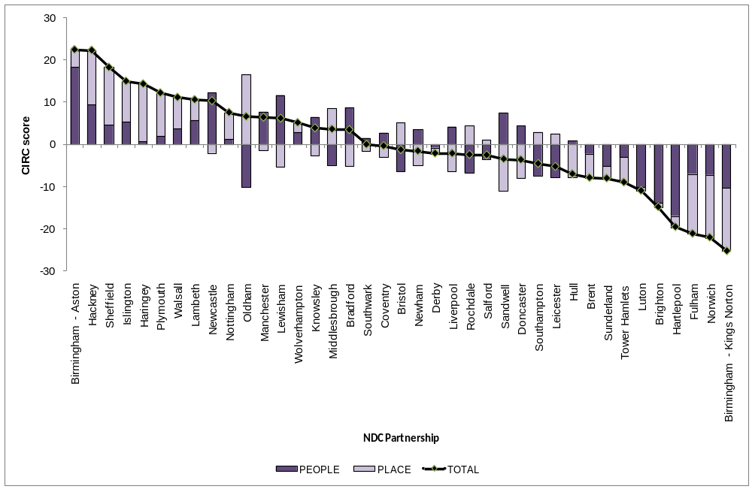
Figure 1 also illustrates for each NDC area the contribution that people-, and place-, based outcomes make towards overall CIRC scores. In this context, indicators on health, education and worklessness have been combined as people-based outcomes and those for housing and the physical environment, crime and community make up the place-based element of the CIRC. Consistent patterns emerge:
- areas which saw most change did so across both elements: 9 of the 10 areas seeing most change had above average change for both people and place-based measures; there is also a tendency amongst these 9 for more overall gains made in the place-based outcomes: approximately two thirds of the overall score achieved; for 7 of the ten areas seeing greatest change, the place-based element of the score taken alone would have placed these areas in those ten seeing greatest place-based change
- conversely 9 of the 10 NDC areas seeing least change had below average scores for both people and place-based outcomes; for 6 of these areas the people-based score would have placed them in a list of the ten areas seeing least change.
Figure 2 illustrates the complexity of change achieved across NDC areas. For some, reasonable change in certain outcomes can in part be offset by less than average change on others. For example Oldham was ranked first of all the NDC areas on the basis of the benchmarked relative change for all place-based outcomes: second on crime, second on housing and fifth on community. However, this area ranks in the bottom ten for all three people-based outcomes: education, worklessness and health. These scores combine to place Oldham tenth in the overall rankings.
Birmingham Aston is unusual compared with other top ranking NDC areas, in that it saw relatively modest above average gains for place-based outcomes, but relatively much more change in education, worklessness and health: first, first and second on benchmarked relative change achieved for each of these outcomes respectively.
Figure 2: Thematic components of overall CIRC score, by Partnership
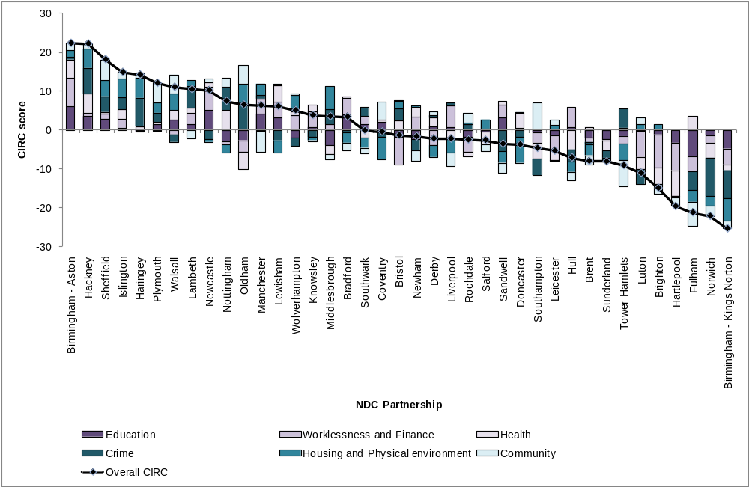

4

NDC areas seeing most and least change: a detailed analysis
To illustrate the range of outcomes which underpin CIRC scores, the following section looks in-depth at two NDC areas. One of these Hackney, saw more change than virtually any other NDC area; Birmingham Kings Norton on the other hand saw least. A rank of 1 represents the least deprived or greatest change achieved, 39 the most deprived or least change over time.
Hackney is examined rather than Birmingham Aston which is ranked first, as it is more typical of those NDC areas seeing greatest change (see Figure 1). Whilst NDC areas seeing greatest change tended to see most gains in relation to place-based outcomes, this is not true for Birmingham Aston.
Hackney was one of the more deprived NDC areas at the beginning of the period being ranked 28th of all 39 NDC areas in 2002. It was close to the Programme wide average on people-based outcomes: worklessness, education and health. There were more obvious issues in relation to place, the NDC area being ranked, for example, 34th for both housing and the physical environment and also community outcomes. Hackney was within the top ten areas (least deprived) for only two of the 36 indicators at the beginning of the period. This compares with an average of nine indicators across all areas.
Hackney improved its rankings on the CIRC score for each additional two year period rising from 13th in 2002-2004, to fourth by 2002-2006, to second by the end period. In addition it was first in terms of unbenchmarked relative change between 2002 and 2008. The steady improvement over time was seen across both people and place outcomes. The area moved from having mid ranking CIRC scores for people and place in the first two year period, to being in the top ten by 2006, and by 2008 was ranked fourth for both. Change was especially evident between 2002 and 2008 in education, health, crime, and housing and the physical environment: the NDC area was within the top five CIRC scores for each of these outcomes.
This scale of change can be illustrated by examining a selection of indicators which underpin the CIRC scores for 2002-2008. Hackney showed the biggest net improvement in satisfaction with the area as a place to live. The increase of 23 percentage points was 18 percentage points higher than the 5 percentage points seen in its pooled comparator areas over the same period. This NDC area also had the greatest net reduction in the proportion of residents who smoke. The decline of 12 percentage points was 9 percentage points higher than the 3 percentage points seen in the benchmark areas. Declines in the proportion of residents feeling unsafe after dark and perceiving fewer problems with lawlessness and dereliction in the area were also ranked fourth and fifth respectively for benchmarked change achieved.
By the end of the period Hackney had moved up rankings based on unbenchmarked relative change: from 19th in 2002 to ninth by 2008. Improvements in rankings were seen for 26 of the 36 indicators utilised in CIRC. For 15 indicators Hackney was in the ten NDC areas (least deprived) by 2008. This was true for only two indicators in 2002. Conversely the area was only ranked in the bottom ten for three indicators compared with an average of nine across all 39 Partnership areas. Overall Hackney NDC saw considerable change both relative to its pooled benchmark areas and relative to other NDC areas.
Birmingham Kings Norton on the other hand is ranked 39th on the basis of its CIRC score. It should be remembered that this does not mean improvements were not made in some indicators. In some instances changes may be more than those occurring across pooled comparator areas. But on average net change after benchmarking was not as much as that occurring in other NDC areas.
In 2002 Birmingham Kings Norton was actually on a par with Hackney for levels of deprivation (27th versus 28th). The initial position of Birmingham Kings Norton for baseline place indicators was similar to the Programme wide average. The picture for people-based outcomes was more mixed with fewer problems apparent for education, greater issues for worklessness and the area was ranked in the bottom five of all NDC areas with regard to health. Only four of the 36 indicators at the beginning of the period were within the ten least deprived NDC areas; for eight indicators Kings Norton was in the ten most deprived areas. Again, this is not entirely dissimilar to the original position of Hackney where the respective figures are two and seven.
Birmingham Kings Norton saw the second smallest unbenchmarked relative change of all areas between 2002 and 2008. One of the 36 indicators fell within the ten areas seeing most positive change. Conversely for half of all indicators the area was within the ten areas seeing least change. By the end of the period Birmingham Kings Norton had slipped down the rankings on unbenchmarked relative position. This area had moved from being the 27th most deprived area in 2002 to the 35th by 2008. There was a decline relative to other NDC areas for 26 of the 36 indicators. For only two indicators was the area within the top ten NDC areas (least deprived) by 2008 compared with four indicators at the beginning of the period. Conversely the area was ranked in the bottom ten for 20 indicators compared with eight in 2002.
When the CIRC score is used to consider change after benchmarking against pooled comparator data, not surprisingly a similar pattern of relatively limited change emerges. It was ranked second from last on its CIRC score in the 2002-2004, performed slightly better by 2002-2006 at 32nd; but by 2008 had fallen to 39th.
When the CIRC score is considered by outcome, both people and place elements of the Index had low rankings for the 2002-2008 period. However, this masks the fact that CIRC scores for the health and community elements of the Index were ranked 26th, not far off the Programme wide average. However, for none of the 36 indicators did the area come within the ten areas seeing greatest benchmarked change; for 18 the area was in the bottom ten, for ten in the bottom five.
The smaller benchmarked change relative to other NDC areas for 2002-2008, can be illustrated by examining a selection of indicators which underpin CIRC scores. Birmingham Kings Norton was 32nd in terms of net improvement to satisfaction with the area as a place to live. There was an increase between 2002 and 2008 of 7 percentage points for satisfaction with area; but this was on a par with change seen in its pooled comparator areas. This therefore leads to a net gain of zero compared with a Programme-wide average of 6 percentage points higher than comparator areas. The area also had the 34th lowest net reduction in the proportion of residents feeling unsafe after dark. The decline of six percentage points was half the 12 percentage points fall seen in the benchmark areas. Declines in the burglary rate, and proportion of residents perceiving fewer problems with lawlessness and dereliction in the area, were also ranked 37th and 35th respectively for benchmarked change. Overall although improvements in the area were made, these were relatively small compared with both its pooled benchmark areas and also against other NDC areas.

5

To what extent does deprivation determine change?
The absolute baseline position of NDC areas relative to the other 38 can be examined using a combined z-score based on the 36 CIRC indicators. The relationship between levels of deprivation at the start of the Programme (2002) can then be compared with: absolute position by the end of the period; unbenchmarked relative change; and the final benchmarked CIRC score.
Correlation coefficients confirm that when the entire period of change (2002-2008) is considered there is a significant, although not very strong, negative relationship between starting position and unbenchmarked relative change achieved (-0.42, significant at the 1% level). There is some evidence that the most deprived of NDC areas tended to make greater absolute improvements over time. This may in part reflect greater headroom for change. For example, it may be easier to decrease an unemployment rate in an NDC area if levels at the beginning of the period were high compared with another NDC area which already displayed rates similar to the national average.
Figure 3 illustrates this relationship. Zero represents the Programme wide average, negative scores represent a greater intensity of problems, and positive scores a relatively more favourable starting position. The goodness of fit R² statistic of 0.18 indicates that approximately 18 per cent of the variation in levels of unbenchmarked relative change achieved can be accounted for by baseline position. Ultimately this relatively low R² points towards other unidentified factors as having more of a bearing on change.
Figure 2 is colour coded by the typology of NDC areas (see Chapter 7) to highlight the degree of problems evident in different types of area at the beginning of the Programme. A fuller discussion of clusters of NDC areas is developed later in this report. The cluster 1 'entrenched disadvantaged' group of Partnerships stand out as having the most serious of problems at the beginning of the Programme. This group of five stand apart from the rest by some considerable degree. All five also achieved above Programme wide average absolute change. Cluster 3, containing the London Partnerships, tends to be concentrated towards the other end of the spectrum. Seven of the ten areas with least problems at the beginning of the period are in London. Only Southwark and Hackney buck this trend. Members of the 'stable and homogenous' cluster 2 display a full range of circumstances seen across all Partnerships at the early stages of the initiative.
Figure 3: Baseline position compared with unbenchmarked relative change
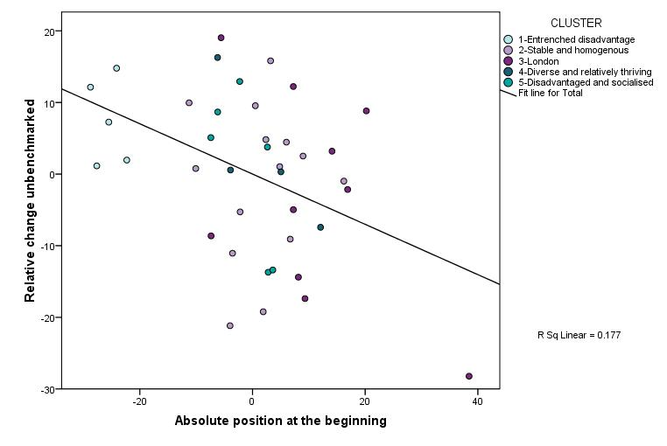
Birmingham Kings Norton
Norwich
Nottingham
Fulham
Hackney
Islington
Walsall
Brent
Doncaster
Haringey
Southwark
Birmingham Aston
Sheffield
It is interesting to compare the scatter chart in Figure 3 with the earlier overall ranking of NDC areas on the basis the final CIRC score provided in Table 2 and Figure 2. NDCs which are furthest away from the line of best-fit are the ones which differ most from that relationship linking starting point with unbenchmarked relative change achieved. Therefore Hackney, Islington, Haringey and Walsall made the greatest unbenchmarked relative change over and above that which might be expected for areas with a similar level of deprivation at the beginning of the Programme. All these areas are in the list of seven areas seeing most change on the basis of the overall (benchmarked) CIRC score: second, fourth, fifth and seventh respectively. Birmingham Kings Norton and Norwich on the other hand saw less change than might have been expected if overall starting position alone was considered. These are the two areas seeing least change.
Fulham is notable in Figure 3 due to the extent of problems in the area at starting point being far less than across other NDC areas. This NDC area also saw less unbenchmarked relative change than might have been expected, even given its better initial starting point. If Fulham is excluded from analyses, then the negative relationship between starting position and unbenchmarked change achieved still exists but weakens further and is no longer statistically significant (correlation coefficient -0.29).
After benchmarking change against that occurring in comparator areas, then the correlation between CIRC and starting position weakens considerably and is no longer significant. This is the case if either all 39 NDCs or the 38 excluding Fulham are considered. Therefore once progress is calibrated in relation to a group of non-NDC deprived areas situated in a similar context, then the most disadvantaged NDC areas in 2002 were not necessarily those seeing above average change.
Figure 4 shows the relationship between absolute position of NDC areas relative to each other at the beginning and end of the 2002 to 2008 period. This shows a strong correlation between the start and end position (0.73, significant at the 1% level). The best-fit regression line gives an R² of 0.53 or that just over half the variation in position by the end of the Programme can be explained by where NDCs started off. Therefore NDC areas with the most entrenched problems at the beginning tended still have the worst position relative to other NDC areas by the end of the period even after showing improvements over time.
Figure 4: Baseline position compared with 2008 rank
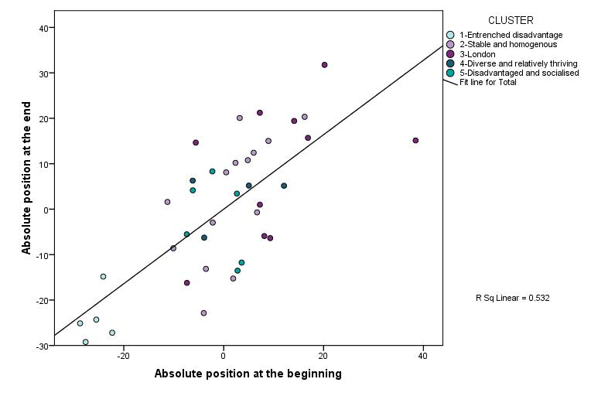
Fulham
Islington
Hackney
Haringey
Walsall
Nottingham
Birmingham Kings Norton
Norwich
Birmingham Aston
Doncaster
Sheffield
Sunderland
Oldham

Figure 5 shows how closely the two indices of change are related to each other (correlation coefficient 0.87 significant at 1% level). This shows that the areas seeing largest absolute changes against other NDC areas, also tended to make the largest changes relative to their pooled comparator areas. NDC areas appear to fall into two groupings either side of the best fit line. For areas in clusters 1 and 2 displaying entrenched disadvantage and those characterised as stable and homogenous, their CIRC score is lower than might be expected given the level of absolute change achieved. This indicates that improvements have been made in both the NDC areas and in the similarly deprived areas within the same group of local authorities within their cluster. For members of clusters 3-5 however gains tend to be greater than those occurring in their pooled comparator areas. Two reference lines have been added which represents Programme wide averages. The top right hand quadrant of the chart contains NDC areas which saw above average change both relative to other areas and also against pooled comparator areas.
Figure 5: Benchmarked/ unbenchmarked change

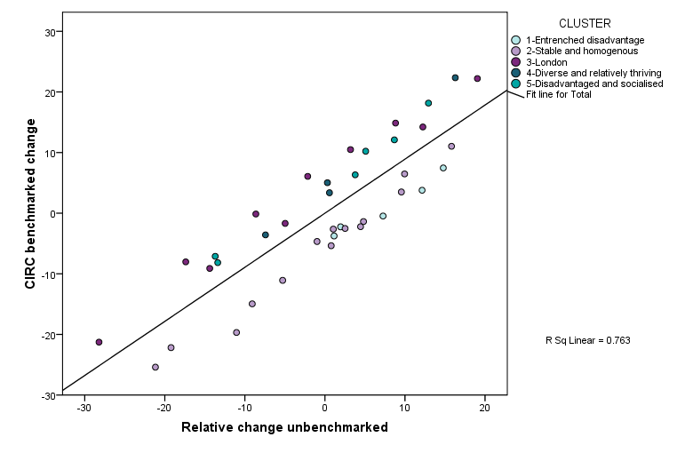
Fulham
Birmingham Kings Norton
Norwich
Hartlepool
Birmingham Aston
Knowsley
Sheffield
Hackney
Leicester
Brent
Islington
Walsall
Southwark
Lewisham
Haringey
Oldham
Nottingham
Middlesbrough

6

Progress over time
The CIRC analysis was undertaken at earlier stages of the evaluation to track change over time. Previous versions have used slightly different baskets of indicators or explored alternative methodologies. For this paper all the data has been compiled on a comparable basis over time.
There are interesting changes in the rankings of NDC areas over time. NDC areas which saw more change in earlier stages of the Programme are not necessarily the same as those doing well over the entire period. This is not entirely surprising. Some areas may have seen quick gains in earlier periods of the Programme via visible interventions noticed by a large proportion of the local population: tackling issues to do with the local physical environment, introducing neighbourhood wardens, reducing crime, and so on. For other areas undertaking large scale re-development projects, disruption may dampen down residents' attitudes towards the area in the early years, positive impacts only becoming apparent in later years.
Exploring correlations between CIRC scores in each of the two year periods adds weight this theory. Areas seeing change over the first two years also tended to be the ones which saw more positive change over the initial four year period. This trend was consistent for people or place-based outcomes, as well as overall performance (correlation coefficients 0.75, 0.77 and 0.74 respectively, all significant at 1 per cent level).
There is a positive relationship between NDC areas which saw most change over the entire period 2002-2008 and those seeing more positive change in the first two or four year period considered. However, this relationship is much weaker than that between change in the first two years compared with the first four (0.44 and 0.49 respectively, significant at 5% level). In the main this is due to change in place-based scores over time. NDC areas which saw more change on the 18 indicators relating to housing and the physical environment, crime or community in the first two years, tended to still be seeing such change by the end of the four year period. However, by 2008 some NDC areas which previously scored less well had caught up or overtaken some areas which had previously seen more change.
The CIRC score based on people-based outcomes stayed relatively stable over the periods considered i.e. the ones that saw more change in the first two years, tended to do so over the entire six year period.
This is an important message for evaluations of long term interventions such as NDC: the entire period of change needs to be considered if the true scale of any impact is to be measured.

7

Change across clusters of NDC areas
Previous work carried out by the national evaluation team identified a five-fold clustering on the 39 NDC areas. Areas in Figure 6 are colour coded to reflect this typology. These groupings are based on how similar these areas were to each other in relation to the 36 indicators at the beginning of the Programme. In addition, levels of residential mobility within each NDC area was also taken into account in defining these clusters.
Figure 6: CIRC score 2002-2008, by Partnership
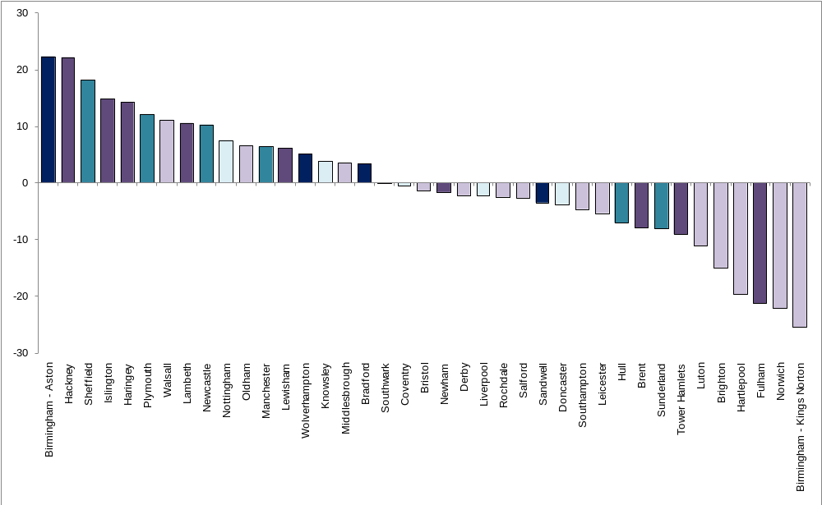
Key: |  | Cluster 1 - Entrenched disadvantage
 |  | Cluster 2 - Stable and homogenous
 |  | Cluster 3 - London
 |  | Cluster 4 - Diverse and relatively thriving
 |  | Cluster 5 - Disadvantaged and socialised

Partnerships contained within each cluster are as follows:

- Cluster 1 - Entrenched disadvantage
Liverpool
Nottingham
Knowsley
Doncaster
Coventry.

- Cluster 2 - Stable and homogenous
Norwich
Middlesbrough
Leicester
Brighton
Bristol
Walsall
Southampton
Salford
Oldham
Rochdale
Hartlepool
Derby
Birmingham Kings Norton
Luton.

- Cluster 3 - London
Hackney
Newham
Southwark
Lewisham
Brent
Islington
Haringey
Fulham
Lambeth
Tower Hamlets.

- Cluster 4 - Diverse and relatively thriving
Bradford
Sandwell
Wolverhampton
Birmingham Aston.

- Cluster 5 - Disadvantaged and socialised
Newcastle
Hull
Manchester
Sunderland
Sheffield
Plymouth.

Table 3 highlights some of the key characteristics of the clusters.
Table 3: Key characteristics of NDC clusters
 | Percentage of respondents in 2002
 | Non-white | Live in the social rented sector | Live in a working age workless household¹ | Working age with no qualifications²
Cluster
1 – Entrenched disadvantage | 13 | 59 | 55 | 36
2 – Stable and homogenous | 7 | 51 | 35 | 34
3 – London | 47 | 67 | 38 | 26
4 – Diverse and relatively thriving | 57 | 39 | 39 | 40
5 – Disadvantaged and socialised | 17 | 64 | 49 | 39
All NDCs | 24 | 57 | 41 | 33
Comparator | 23 | 42 | 32 | 28
Source: IPSOS MORI NDC household survey 2002
* as %of respondents living in households with at least one person of working age
** as % of working age respondents
Figure 7 presents the average, minimum and maximum CIRC scores for each cluster. The diverse and relatively thriving cluster 4 has the highest average score but his is heavily influenced by the strong performance of Birmingham Aston within this group. The average score for the disadvantaged and socialised cluster 5 is close behind.
Figure 7: Average CIRC score for each NDC cluster
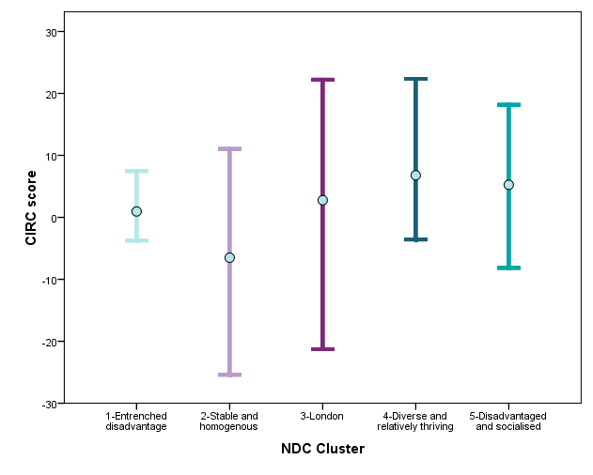
Figure 8 shows that for some groupings of NDC areas above average performance for people-based outcomes is offset to a greater or lesser extent by below average progress on place-based measures (clusters 1 and 4). In other clusters progress is above average across both people, and place, -based elements of the Programme (clusters 3 and 5).
Figure 8: People and place components of overall CIRC score, by cluster
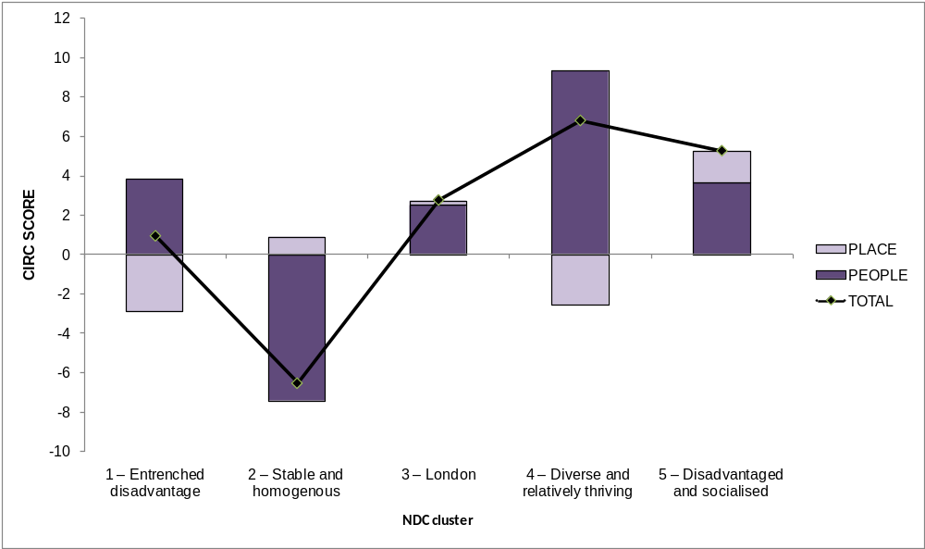

8

Detailed analysis of each cluster
This typology of NDC areas allows progress to be assessed for groups of areas with similar characteristics at the outset of the Programme. Each cluster also shares the same pooled comparator areas for benchmarking purposes.

Cluster 1: Entrenched disadvantage'
At the time of the first household survey in 2002, NDC areas in this cluster were characterised by high levels of worklessness, and a poorly qualified working age population which suffered from poor general and mental health. Consequently residents were more likely to be on low incomes or be benefit-dependent than was the case in other clusters. The population was relatively unstable, with residents more likely to want to leave, or feel ‘trapped’ (wanting to leave but being unable to do so), and a relatively high proportion was dissatisfied with their accommodation, the area and overall quality of life. Residents were also less likely to feel part of the community. Of all the clusters, these areas were most likely to have high fear of crime, high recorded crime rates and area-related problems such as dereliction. Neighbourhoods in this cluster appeared to suffer the most systemic problems of all, and they are therefore referred to in terms of ‘entrenched disadvantage'. These areas stand apart from the others as having the greatest levels of deprivation at the beginning of the period. The average rank for the group in 2002 was 37.
Figures 7 and 8 depict the CIRC score for each cluster. These show that the entrenched disadvantaged group was close to the Programme wide average for overall benchmarked change achieved. If the average rank of the CIRC scores for each member of this group is considered then gradual improvement over time can be seen; rising from an average rank of 24 in the 2002 to 2004 period, to 22 by 2006 and 19 by 2008.
This cluster saw considerable people-based change with the average rank on CIRC rising from 25 for the first two year period to 14 by the end period. All five areas within this cluster achieved above average benchmarked change for the people element of the CIRC between 2002 and 2008. The group did well on health (average rank 13), outperforming the change achieved in pooled comparator areas for four of the six indicators within this theme. Above average net gains for worklessness indicators were also made (average rank 14) outperforming their pooled comparator areas on five of the six indicators within this theme. Performance on the education indicators was closer to that seen across all NDC areas (average rank of 19).
The cluster 1 average benchmarked relative change for place-based issues was below that seen across the Programme (average rank 26). Amongst this group only Nottingham achieved above average CIRC scores for the place element of the index between 2002 and 2008. The crime and community CIRC scores were, however, on a par with the Programme wide average.
The below average CIRC score for place was therefore influenced by the housing and the physical environment indicators (average rank 32). However, examination of the unbenchmarked change data shows that housing and the physical environment indicators for entrenched disadvantaged NDC areas improved substantially over time: five of the six indicators were above the Programme wide average change achieved. For example, an additional 15.7 per cent of residents were satisfied with the area by 2008 compared to 2002; this was greater than the 13.4 per cent seen across all NDC areas, and the highest unbenchmarked change for any cluster. The low housing and the physical environment CIRC score therefore reflects the fact that the comparator areas within cluster 1 local authority districts also saw positive improvements over the same period; an increase of 16.1 per cent on this one indicator was higher than that seen in cluster 1 NDC areas. This pattern is repeated for many of the indicators in this theme. One possible interpretation is that improving housing and the physical environment was a priority in these local authority areas and alternative funding sources may have been utilised across local deprived areas (including the comparator areas) to deliver improvements.
Overall, this group of NDC areas had high levels of deprivation at the beginning of the period and remained relatively disadvantaged compared with other NDC areas by the end. In the main progress was made across the majority of outcome areas which was equal to, or above, Programme-wide averages.

Cluster 2: Stable and homogenous
In 2002 the fourteen areas in this cluster were characterised by relatively stable, predominantly white populations. NDC residents in this cluster were most likely to be satisfied with their accommodation and to think that their quality of life was good. They were also more likely to want to stay in the area and did not feel as 'trapped' as residents in other clusters. A relatively high proportion of respondents in these NDCs felt that neighbours in these areas looked out for one another. There were relatively high rates of dissatisfaction with the area as a place to live, and also problems such as lawlessness and dereliction, high theft and overall recorded crime rates. Levels of individual deprivation were, however, less than in the other clusters. Residents were on average healthier, better qualified and more skilled, with a greater degree of engagement with the labour market, than was true for their counterparts in other clusters. Consequently there was a smaller proportion of households who were benefit-dependent or on low incomes. However, residents within this cluster were least likely to think that the area had improved in recent years. Areas in cluster 2 are described as ‘stable and homogenous’.
This cluster of NDC areas displayed an overall level of deprivation on a par with the Programme average. In 2002 NDCs in this cluster were spread across the full range of circumstances with two in the top ten least deprived areas, two in the bottom ten most deprived, and the rest spread across the mid-range. This group had an average rank of 20.
Cluster 2 on average experienced the lowest benchmarked change for any of the five groups. In the first two year period the average rank based on CIRC scores was 23 but by 2008 this had fallen to 26. Only three of this group of 14 areas managed to achieve benchmarked change above the Programme wide average for the 2002-2008 period. Conversely five of the six lowest CIRC scores for least benchmarked change made were within this group.
The low overall CIRC score was a consequence of limited nature of change for the people element of the Index. The group had an average CIRC rank of 31 for people-based outcomes between 2002 and 2008. Potentially, one explanation could be that because these issues were relatively less of a problem for this group at the beginning of the Programme, compared with the case for other clusters, so less attention was placed on them. In 2002, this cluster exhibited less deprivation than the Programme wide average for 14 of the 18 people-based indicators. However, the benchmarked change recorded for these 18 indicators was only greater than that occurring in the pooled comparator areas for one education indicator and four health indicators. Only one NDC area of the 14 in this group managed to achieve above average benchmarked change in relation to worklessness.
There was more positive change in relation to place-based outcomes. Above average benchmarked change for place was achieved between 2002 and 2008 (average rank 17). Greater gains were seen in housing and the physical environment and community elements of the index (average ranks 17), compared with crime (average rank 21). For example, this group outperformed its pooled comparator areas on four of the six housing and physical environment indicators and also contained the top two housing CIRC scores.
At the beginning of the period, this group of NDC areas displayed less deprivation in relation to people-based outcomes, more deprivation in relation to place and overall was on a par with the Programme wide average. On the whole, the rate of change did not keep pace with that occurring in pooled comparator areas for people-based outcomes. Consequently, a marginal decline in final position for these indicators was seen: a cluster average rank of 17 in 2002 and 18 by 2008. However, for place-based outcomes the better CIRC score led to an improvement in relative absolute position for these issues: group average rank 24 in 2002 and 18 by 2008.

Cluster 3: London NDCs
The third cluster is self-defined by its geography. On various characteristics, London NDCs differed markedly from elsewhere. They were more ethnically diverse areas than average, as one might expect, with higher concentrations of social housing. Respondents in this cluster were the most dissatisfied with their accommodation, the most likely to feel trapped and to want to move. They were the least likely to think neighbours look out for each other; and were less happy with the quality of life in the area. However, fear of crime, recorded crime and problems with lawlessness, dereliction or the local environment were similar to, or below, the average for NDCs as a whole. Residents were, on average, the least deprived, and these 10 neighbourhoods had the healthiest, best qualified and most skilled working age population. Residents were the least likely to be registered unemployed or be on Incapacity Benefit, and had the lowest concentrations of benefit dependency or low income households. London NDC households also had the best school results of all the groups.
The combined standardised data on the beginning position for the 36 indicators confirms the more favourable position of London NDC areas relative to the other clusters: the average rank in 2002 was 11. This average rank was substantially higher than other clusters; the diverse and relatively thriving cluster 4 Partnership areas had the next highest average rank of 19. Seven of the ten least deprived NDC areas were in London. On average, these London NDCs had 14 of the 36 indicators within the ten least deprived areas. As highlighted above local problems were far more likely to be associated with place (average rank 19), rather than people (average rank 8).
London NDCs experienced benchmarked relative change which was slightly above the Programme wide average between 2002 and 2008 (average rank 17). This average reflected a range of circumstances across the group with four in the top ten areas for benchmarked change (Hackney, Islington, Haringey and Lambeth) and three in the bottom ten (Brent, Tower Hamlets and Fulham). London NDCs also saw slightly better progress in the 2002-2004 and 2004-2006 period (average rank 15 and 13 respectively) then for 2002-2008. This may be because the rate of change slowed in London NDC areas or alternatively that for a number of other areas a growth spurt was seen in the final two year period which enabled them to overtake the London NDCs on CIRC.
The overall 2002-2008 CIRC score reflects greater progress in relation to the people element of the index (average rank 16), compared with the place-based outcomes (average rank 20). This is interesting given that the initial assessment of issues in London NDCs tends to highlight place, rather than people-related problems. It is generally the case that more problematic outcome areas at the start of the Programme which make most gains. The average CIRC scores for the London NDCs were particularly good for health (average rank 12); for five of the six health indicators the cluster average benchmarked change was greater than in pooled comparator areas. London NDC areas also saw slightly better than average change with regard to worklessness (average rank 18): four of the six indicators saw NDC areas seeing more change than did the London comparators.
Place-based outcomes for London NDC areas were on a par with the Programme wide average. However, this is mainly because of better progress for crime (average rank 16). There were lesser gains for average benchmarked change on housing and the physical environment (average rank 20) and community (average rank 25). On average, this group saw the most positive improvements on crime indicators of all clusters with five of the six indicators recording more change than the London benchmark areas.
At the end of the Programme (2008), London NDC areas still displayed least deprivation in relation to people-based outcomes and overall deprivation. However, the group saw a marginal decline in terms of final position on indicators overall: group average rank 11 in 2002 and 14 by 2008. This pattern was seen in both people-, and place-, based outcomes. This implies that although the London NDC areas continued to improve from an already relatively better absolute position, and at a faster rate than their pooled comparator areas, this was not by quite as much as were gains recorded in some of the other clusters. The mixed performance seen across the individual London NDC areas is also worth noting. Brent, Tower Hamlets and Newham, all originally within the ten least deprived NDC areas, declined by an average of 16 places down the rankings. However, Haringey moved from being 11th to second and Hackney moved 19 places to be ninth overall.

Cluster 4: Diverse and relatively thriving
In 2002 this group of four NDC areas was the most ethnically diverse of all the clusters, with 57 per cent of the total resident population from black and minority ethnic communities. Taken together, these areas also had the lowest proportion of social housing. Residents in this group were below average for a range of health measures. The proportion of households on low incomes, mean tested benefits, and the employment rates of those of working age were all similar to the NDC average. These areas in this cluster could be seen as relatively stable, and satisfaction with accommodation was similar to the NDC average. A below average proportion of residents wanted to move, although a slightly higher than average proportion felt ‘trapped’. Total recorded crime rate was the lowest of all the clusters, as were perceived problems with lawlessness and dereliction. However, burglary rates were relatively high and households in this group had the highest fear of crime and more residents felt unsafe after dark than the overall average. Other area level characteristics were generally favourable: relatively high proportions of residents had a ‘sense of community’, thought they could influence decisions in the area, and felt that neighbours ‘looked out for each other’. However, a below average proportion of residents felt that the area had improved in the past two years or that the quality of life was good. The areas in this group are termed ‘diverse and relatively thriving’.
The four NDC areas within this cluster exhibited levels of deprivation in 2002 similar to the Programme average. The group ranged from Sandwell being ranked sixth least deprived to Birmingham Aston ranked 30th. For the group as a whole, people-based indicators had an average rank of 23, place-based issues 15.
On average this group experienced the greatest benchmarked change of any of the clusters, being slightly ahead of those areas in cluster 5 (disadvantaged and socialised). However, if the average rank is examined rather than the average CIRC score then both clusters have an average rank of 15. The contribution to the CIRC score made by Birmingham Aston, ranked first of all 39 NDC on relative benchmarked change, brings up the group average considerably: the average rank is 15 when Birmingham Aston is included, 19 when it is excluded.
The diverse and relatively thriving cluster 4 was not the best performing group of Partnership areas consistently over time. In the first two years of change data (2002-2004) this group had an average rank of 23, falling back to 33 by 2006. Hence change in some outcome areas quickened significantly in the last two year period: 2006-2008.
There are two potential explanations for this. First, large scale re-development programmes are occurring in some areas in this cluster e.g. Bradford. These can cause disruption in the early years and not result in positive outcome change until later in the Programme. This may be borne out by the low average rank on CIRC for place-based issues: in 2002-2004 the average rank was 34, which fell even further by 2006 to 37, but recovered by 2008 to 24. In both earlier periods all four areas within this group were in the bottom ten for benchmarked change achieved in relation to place. By 2008 only Sandwell still fell into this category. The lowest CIRC score of any outcome area for cluster 4 was in the housing and the physical environment dimension to the Index: average rank of 34 2002-2004, 37 2002-2006, but rising to 21 by 2002-2008.
A second possible explanation for the low CIRC score on place-based issues may be that their pooled comparator areas did particularly well on some issues in the early years. This may in part be due to a focus on reducing crime. All crime rates and crime indicators for the cluster 4 comparator areas fell steadily from 2002 to 2006 but rose noticeably again in 2008; this trend was not replicated in other comparator area groupings. Other funding streams to improve housing and the physical environment or community cohesion in deprived neighbourhoods within these local authorities may also have contributed to improvements in these pooled comparator areas in the earlier years. This is entirely plausible in the case of Bradford where the race riots of 2001 meant that additional resources were targeted in Manningham the comparator area within this local authority district.
The overall 2002-2008 CIRC scores for the diverse and relatively thriving group of Partnerships reflects particularly strong rates of change in relation to the people element of the index (average rank 7). All four areas saw considerable change and by 2008 three of the four were in the top ten benchmarked change, Birmingham Aston being ranked first. All four areas saw considerable change for worklessness (average rank 7), and three of the four for education (average rank 11).
By 2008 cluster 4 was still on a par with average levels of deprivation seen across the Programme (average rank 19). However, the balance as to what type of issues were more prevalent in these areas had shifted as a consequence of consistently positive change in relation to people-based outcomes and the below average benchmarked change for place-based issues. The average rank on absolute position for place fell from 15 to 23 between 2002 and 2008; for people the average rose from 23 to 19. The greatest improvement for an individual NDC area was seen in Birmingham Aston which rose from 30th most deprived to 15th. The outcome area which saw most improvement was worklessness (average rank 24 in 2002 and 15 in 2008).

Cluster 5: Disadvantaged and socialised
These six areas were characterised (in 2002) by relatively high levels of worklessness, and a poorly qualified working age population suffering from relatively poor general health. A high proportion of residents were on low incomes or were benefit dependent. These areas were most likely to suffer from poor school results. There was some evidence too of 'churning', with a comparatively high proportion of residents moving frequently within the past five years. However, residents in these areas were least likely to want to leave or feel trapped. Residents in this cluster were also most likely to be satisfied with the area as a place to live. They were relatively satisfied with their accommodation, felt the quality of life in the area was good, were more likely to feel part of the community and think that neighbours looked out for each other. Overall, residents displayed relatively high levels of ‘bonding’ social capital. Of all the clusters, this group had the lowest proportion of residents expressing fear of crime or feeling unsafe after dark. On the whole, recorded crime was below average and area-related problems such as lawlessness and dereliction and problems with the physical environment were average. A high proportion of residents within this cluster felt that the area had improved in the past two years. Areas in this category are referred to here as ‘disadvantaged and socialised’ places. This group exhibited levels of deprivation in 2002 below the Programme average but not as extensively as was true for those in cluster 1. NDCs in this cluster grouped around the mid-range with Sunderland ranked 16th being the least deprived and Newcastle at 32nd the most.
Issues in this cluster were much more associated with people-based outcomes (average rank 33), rather than place (average rank 6). Five of the six areas were in the ten most deprived in relation to people, on a par with the degree that these problems were seen in the entrenched disadvantage cluster 1. Widespread problems were seen in worklessness (average rank 32), education (average rank 31) and health (average rank 28). Conversely, in 2002 this group had the lowest levels of deprivation seen for the three place-based outcome areas of any cluster: housing and the physical environment average rank 6, community 10, and crime 11.
Cluster 5 saw considerable benchmarked relative change (average rank 15); this was the same average rank as for the diverse and relatively thriving cluster 4. Consistent performance was seen over time; with an average rank of 16 in the 2002 to 2004 period and 17 between 2002 and 2006. However there was a degree of variation across the group with Sheffield, Plymouth, Newcastle, and Manchester all within the top 12 CIRC scores, whereas Hull was ranked 30th and Sunderland 32nd.
The cluster saw considerable change over each period in relation to people-based outcomes with an average CIRC rank of 14 by 2008. Given that these were the most extensive problems in this cluster at the beginning of the Programme then narrowing the gap with other areas on these issues is a positive achievement. Improvements relative to their pooled comparator areas were greatest for education (average rank 12), where these NDC areas experienced more change than the comparators for five of six indicators. Cluster 5 also did well on benchmarked relative change for worklessness indicators (average rank 13).
This disadvantaged and socialised cluster 5 had the least evident deprivation in relation to place-based issues at the beginning of the Programme. The cluster did manage to achieve just above average benchmarked change in relation to place-based issues (average rank 18). However, the picture is mixed across the six areas: Sheffield was ranked second, Plymouth fifth, but Hull 34th.
Overall this group exhibited extensive deprivation at the beginning of the Programme in relation to people-based outcomes and achieved better than average benchmarked change for education, worklessness, housing and community. By 2008, the cluster was in a similar relative position to other NDC areas for levels of deprivation as compared with 2002 (average rank 23 beginning, 22 end). Most positive change was seen in education which improved from an average rank of 31 in 2002 to 25 by 2008. Conversely, other NDC areas tended to see more change in relation to crime which for this cluster fell from an average rank of 11th in 2002 to 19th by 2008.

Birmingham contains two: Aston and Kings Norton
NDC Final Evaluation Reports: The NDC Programme Volume 5: Exploring and explaining change in regeneration schemes: http://extra.shu.ac.uk/ndc/downloads/general/Volume%20five%20-%20Exploring%20and%20explaining%20change%20in%20regeneration%20schemes.pdf
The comparator survey sample consisted of 2,014 respondents in 2002, 4,048 in 2004, 3,062 in 2006, and 3,100 in 2008.
For two NDC specific indicators benchmarks do not exist and straightforward levels of change are used: % residents think NDC has improved the area, % of residents involved in NDC activities.
Standardises indicators so all have a mean of zero and a standard deviation of one
See Technical report

